**Mongodb installation on Ubuntu**

* Go to terminal
* sudo apt install mongodb

**How to start mongodb**

* At terminal type following:
* sudo service mongodb start

note: it may or may not given any error, however, you need to check if mongo is working fine or not as following:

**How to check mongodb if it works**

* mongo

note: it will give certain info along with connecting info as: mongo**://127.0.0.1:27017**

**How to see all collections**

* show dbs;

note: it will show three dbs as admin, config and local all with 0.000GB

**How to create new database**

* use testdb;

note: you will get message ‘switched to db testdb

**How to see database you are currently in**

* db;

note: it will show ‘testdb’

**How to create new collection (table) and insert data**

* db.mycol.insert({ name: ‘jack’, job: ‘designer’, age: 29})

note: you will get a notification as: writeresult( {nInserted” : 1} )

**How to see all collections in a database**

* show collections;

note: mycol

**How to see document (record) as object**

* db.mycol.find().pretty()

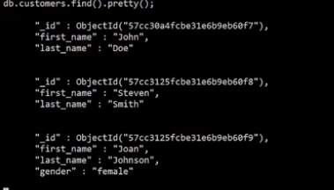

**How to update document**

* db.mycol.update( {first_name: “jon”}, {first_name: ”john”, last_name: “Doe”, gender: “male” } );

note: in real scenario will use _id field which is unique to all documents in a collection

**How to intact the previous key: values while updating**

* db.mycol.update( {first_name: “jon”}, {$set: { gender: “male” } );
* 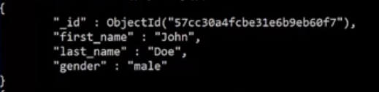

note: in real scenario will use _id field which is unique to all documents in a collection

**How to remove any column/ field**

* db.mycol.update( {first_name: “jon”}, {$unset: { age: 1 } );

**How to any document (row)**

* db.mycol.remove( {first_name: “jon”} );

**How to perform query**

* display all those documents which have city = ‘Boston’



**How to perform sorting**



**How to perform counting**

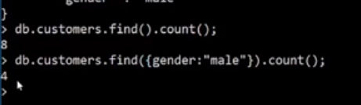

**How to limit displaying number of documents**

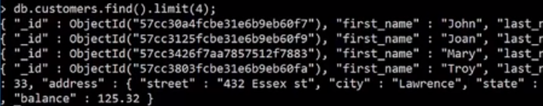

**How to limit displaying number of docs with sorting**



**How to iterate displaying number of docs**

